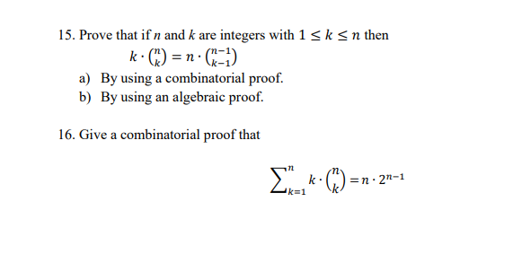

15.

a)

Q:Pick k people from n and one will be leader, how many ways?

LHS: Firstly, pick k group members from n people ,which is C(n,k) , and then pick 1 leader from k group members which is C(K,1)=K

RHS: pick the leader firstly from n people, which is C(n,1)=n, then we can pick k-1 group members from n-1 people, which is C(N-1,K-1)

b)

LHS:k\* n!/[k!(n-k!)]

=n!/[(k-1)!(n-k)!]

RHS:n\* (n-1)!/[(k-1)!\*(n-k)!]

=n!/[(K-1)!\*(N-K)!]

LHS=RHS

16.

N balls be a line, one leader ball is red, the rest can be black or white. How many ways?

○○○○○○○○

RHS:

Take a ball from n to be red, then rest n-1 balls is random white or black, which is 2^n-1

LHS:

Take k balls from n to be white, which is C(n,k) and then pick a white from k white ball to be red, which is C(k,1)=k, when k=1 this is the situation that one red ball ,the others are black ball. When k =n ,it means one is red ball ,the others are white ball. Then we use summation symbol to sum all situations between all black->all white

（m+p） (s) = (m+p) ( p )

( s ) (p) ( P) (S-P) 上下两个括号就是C

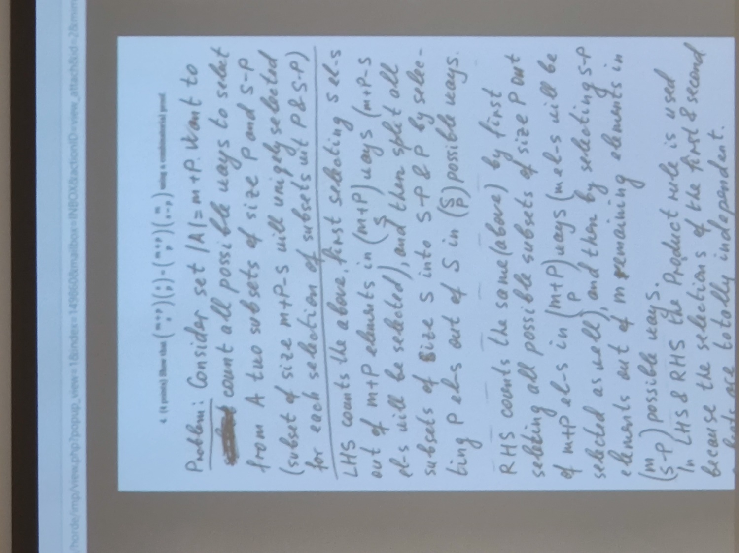

一定要写 In XX possible ways，得分点

1. basic step

N=0 N=1 n=2 如果第三步出现了 an an-1 an-2….有几个未知项，就有几个basic

2.assume for all k<=n

3. then must prove xxxxx